Chapter 6 Sustainability
extra worksheet 3: Polar bears and global warming
Science Understanding Science as a Human Endeavour,
Verbal/Linguistic Logical/Mathematical
Polar bears are found in Greenland, the former Soviet Union, Canada and Alaska. They inhabit the shorelines of the Arctic continents and islands where ice forms each winter. It is from these platforms of ice that polar bears hunt for the seals and young walruses that are their main source of food.
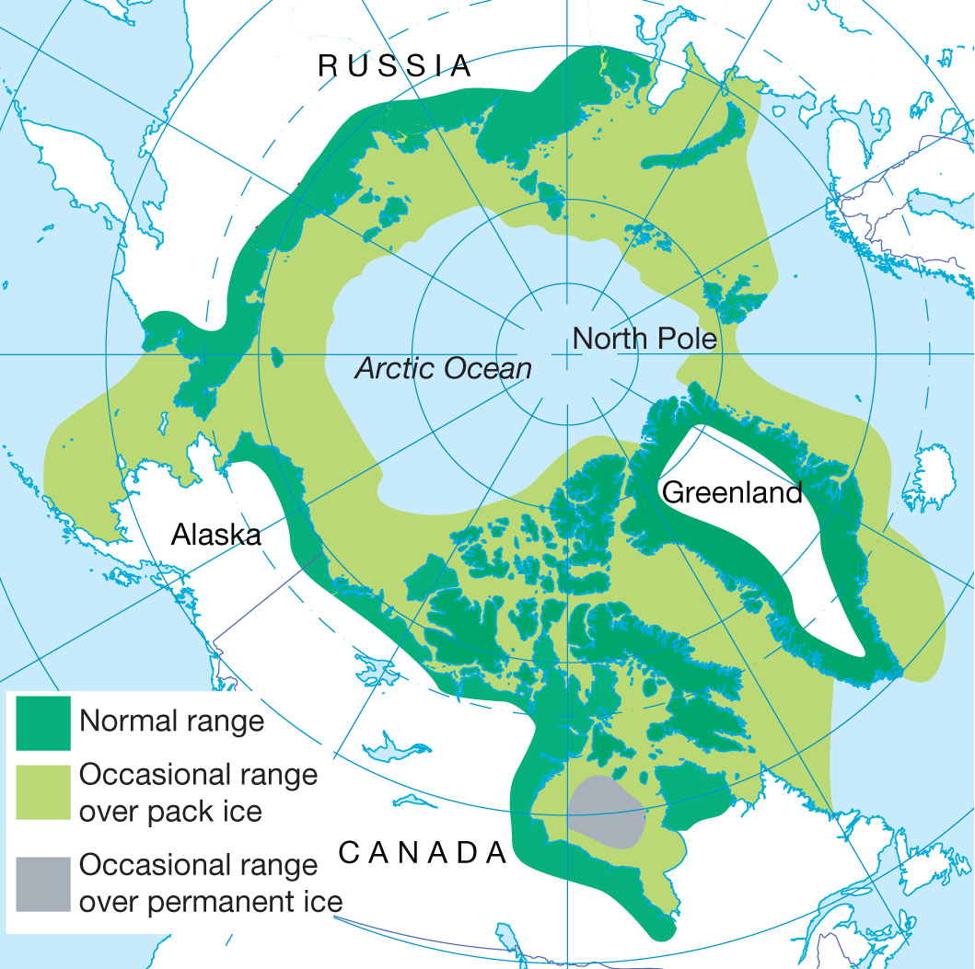
Figure 1
The range of polar bears – shown in green.
The polar bear is classified as a vulnerable species with 8 of the 19 polar bear subpopulations in decline. Vulnerable species are species that are experiencing a rapid population decline and are in danger of becoming extinct if the drop in numbers continues.
Large scale hunting of polar bears by European, Russian and American hunters and trappers from the 1600s right through to the mid-1970s caused international concern about the future of the polar bear. The polar bear population was estimated at 5000 to 10 000 bears in the 1950s and 1960s. In 1973 an international agreement to strictly regulate commercial hunting came into effect. In 2007 the bear population was estimated at 20 000 to 25 000.

Effects of global warming
The International Union for Conservation of Nature now lists global warming as the most significant threat to polar bear populations. Malnutrition (inadequate diet) and starving to death are two possible effects of global warming on polar bears:
• Sea ice is melting earlier in the year. Since polar bears hunt off the sea ice their feeding season is shorter. This means that the bears may not build up sufficient fat reserves to enable them to survive through summer and early autumn when food is in short supply.
• With less sea ice the bears must swim further to capture their food. This increases the rate at which their fat reserves are used up.
• Poor nutrition leads to fewer cubs being born, lower birth weight and an increased death rate for the cubs.
Global warming may also affect the ability of pregnant female bears to build suitable dens in which to give birth to their cubs and tend their cubs for the first weeks of their lives.

Matter of dispute
Not all researchers have reached the same conclusions about the status of polar bear populations.
In a report presented to the United States Senate in 2007, some scientists challenged the computer modelling of the effect of global warming on polar bear populations. Points raised include:
1 Of the 13 populations of polar bears in Canada, 11 are stable or increasing in numbers.
2 In the last 10 000 years, polar bears survived several periods where there was a much warmer climate than there is today.
3 There are a lot more polar bears now than there were 30 years ago. For example, in the Davis Strait area there is a population of 2100 now compared to 850 in the mid-1980s.
Counter arguments put forward by other scientists who do believe that polar bear populations are under threat include:
1 The numbers of bears are increasing because of the controls on hunting both of the polar bear and controls on the hunting of the bears’ food supply – the harp seal.
2 In the area of Western Hudson Bay in north-eastern Canada the population of bears has shrunk by 22% over the last ten years – from 1194 animals in 1987 to 935 in 2004.
3 The population of bears may be increasing in two areas of Canada, but two others are definitely in decline. For the other 15 areas, proposals about the status of the populations cannot be made using the statistics available. Therefore the status for the polar bear population as a whole is unknown.
Table 1 on the following page was presented to a meeting of the Polar Bear Specialist Group (PBSG) in Copenhagen (Norway) in 2009. It was updated in March 2010.
Table 1 Polar bear population numbers and status in each of the 19 areas of its range.
Population | Number  (year of estimate) | Number  (year of estimate) | Current trend | Comments
Arctic Basin | Unknown |  | Insufficient data
Baffin Bay | 2074 (1997) | 1546 (2004) | Declining
Barents Sea | 2650 (2004) |  | Insufficient data
Chukchi Sea | Unknown |  | Declining | Estimate of current trend based on reduction of sea ice and the possibility of illegal harvesting.
Davis Strait | 2142 (2007) |  | Declining | Increased over last 30 years. Current birth and death rates suggest a population decline.
East Greenland | Unknown |  | Insufficient data
Foxe Basin | 2197 (1994) | 2300 (2004) | Insufficient data | New survey is ongoing.
Gulf of Boothia | 1592 (2000) |  | Stable
Kane Basin | 164 (1998) |  | Declining | Current harvesting of bears is unsustainable.
Kara Sea | Unknown |  | Insufficient data
Lancaster Sound | 2541 (1998) |  | Declining | Population thought to be declining because of selective harvest of male polar bears.
Laptev Sea | 800–1200 (1993) |  | Insufficient data
M'Clintock Channel | 284 (2000) |  | Increasing | Low harvest. Population increasing from low numbers.
Northern Beaufort Sea | 1202 (2006) |  | Stable
Norwegian Bay | 190 (1998) |  | Declining | Low harvest. Low productivity. Thought to be declining.
Southern Beaufort Sea | 1526 (2006) |  | Declining | Newly estimated birth and death rates suggest a decline. Amount of sea ice declining rapidly.
Southern Hudson Bay | 900–1000 (2005) |  | Stable | Health and condition of bears has declined.
Viscount Melville Sound | 161 (1992) | 215 (1996) | Insufficient data
Western Hudson Bay | 935 (2004) |  | Declining | Population in mid-1980s – 1200. Decline in population, birth rate, survival rate and condition linked to earlier ice break-up.

Questions
1 Explain what is meant by saying that polar bears are vulnerable.
___________________________________________________________
______________________________________________________________________________________________________________________
2 a Before there was concern about the effect of global warming on polar bear numbers, the numbers of this species were declining. Explain why this was the case.
____________________________________________________________________________________________________________________________________________________________________________________________________________________________________________
b Identify what occurred to reverse the decline in numbers.
____________________________________________________________________________________________________________________________________________________________________________________________________________________________________________
3 Explain why polar bears could become malnourished because of changes caused by global warming.
_______________________________________________________________________________________________________________________________________________________________________________________________________________________________________________________________________________________________________
4 Use data from Table 1 to modify the map in Figure 3 and construct a picture of the change in polar bear numbers.
a Colour in red the areas where data suggest that populations are declining.
b Colour in green the areas where data suggest that populations are stable.
c Colour in blue the areas where data suggest that populations are increasing.

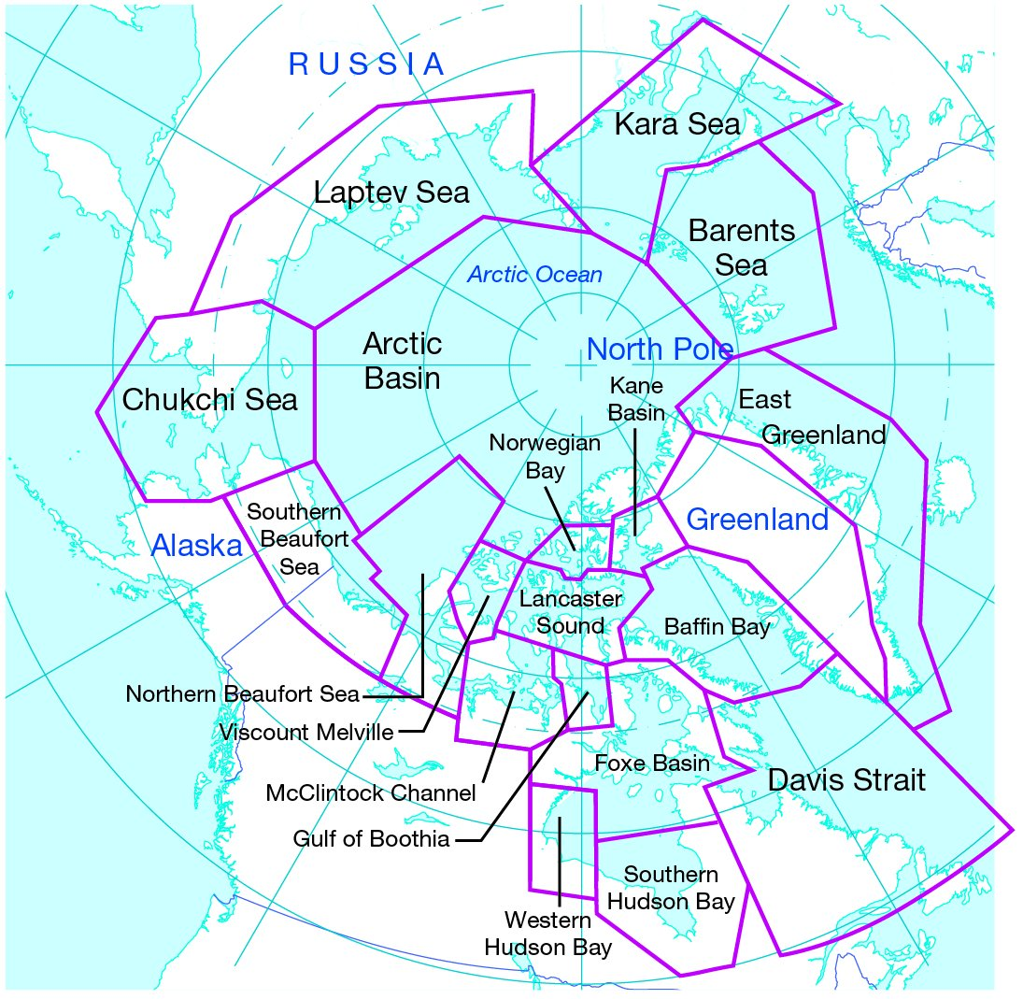
Figure 3
Polar bear populations.

5 Use your completed Figure 3 to compare the percentage of the range of the polar bear about which there is insufficient data with the area about which numbers are known.
_________________________________________________________________________________________________________________________________________________________________________________
6 Compare the area where the population is declining with the area where data suggest populations are increasing or stable.
_______________________________________________________________________________________________________________________________________________________________________________________________________________________________________________________________________________________________________
7 a The current trend in the area of Foxe Basin has not been provided because a new survey is in progress. Assess the information provided and propose how you would classify the population – increasing, stable or declining.
______________________________________________________________________________________________________________________
b Justify your response.
_______________________________________________________________________________________________________________________________________________________________________________________________________________________________________________________________________________________________________

8 Point one in the challenge to computer modelling of the effect of global warming on polar bear populations and point three in the counter argument appear to be using similar data. Compare these two arguments and the way that the data are being used.
_____________________________________________________________________________________________________________________________________________________________________________________________________________________________________________________________________________________________________________________________________________________________________________________________________________________________
9 The increase in polar bear numbers in the Davis Strait area is used as evidence that the bear is not in danger of extinction. The report to the PBSG in 2009 suggested that the population in the same area was declining. Deduce reasons for these different opinions.
_____________________________________________________________________________________________________________________________________________________________________________________________________________________________________________________________________________________________________________________________________________________________________________________________________________________________

